**Personal information**

Title: 232 Intelligent recipe book

Name: Taige Wang

Student number: 713672

Program: Aalto Bachelor's Programme in Science and Technology

Year of studies: 1st year

Data: 11th Feb, 2019

**General description**

The program that maintains a cookbook that can be conveniently searched for a meal that meets the appropriate criteria.

The user of the program has a refrigerator and other cabinets filled with groceries and accurate up-to-date information on how much of everything is in stock. The program can search for dishes that can be prepared either without going to the store or with N additional ingredients if the storage has some or none of the ingredient.

In addition, one can search for recipes using the ingredients.

Foods may be labeled with an allergic factor. (For example, milk, cream, etc. containing lactose) The program must be able to restrict the search so that the desired allergens are avoided.

Some raw ingredients can also be cooked from the recipes. For example, the recipe for minced beef meat contains meatloaf paste, which has its own recipe. Correspondingly, Christmas cakes are made of a dough, which can also be self-made. If the refrigerator does not have puff pastry dough, the program should try to create it from raw materials.

Self-evidently some substances such as eggs and onions can be counted per piece. However, many raw materials are measured differently. Flour is sold in kilograms, but measured in decilitres in recipes. Implement a class that handles all conversions between dimensions. (tip: density)

A general description of what you are doing. This section can be in most cases be copied from the assignment description. Please, specify where appropriate, more details of the assignment as far as you consider it necessary. If it is possible to implement the topic in different levels of difficulty, state also on what level you are thinking of completing the project.

**Draft user interface**

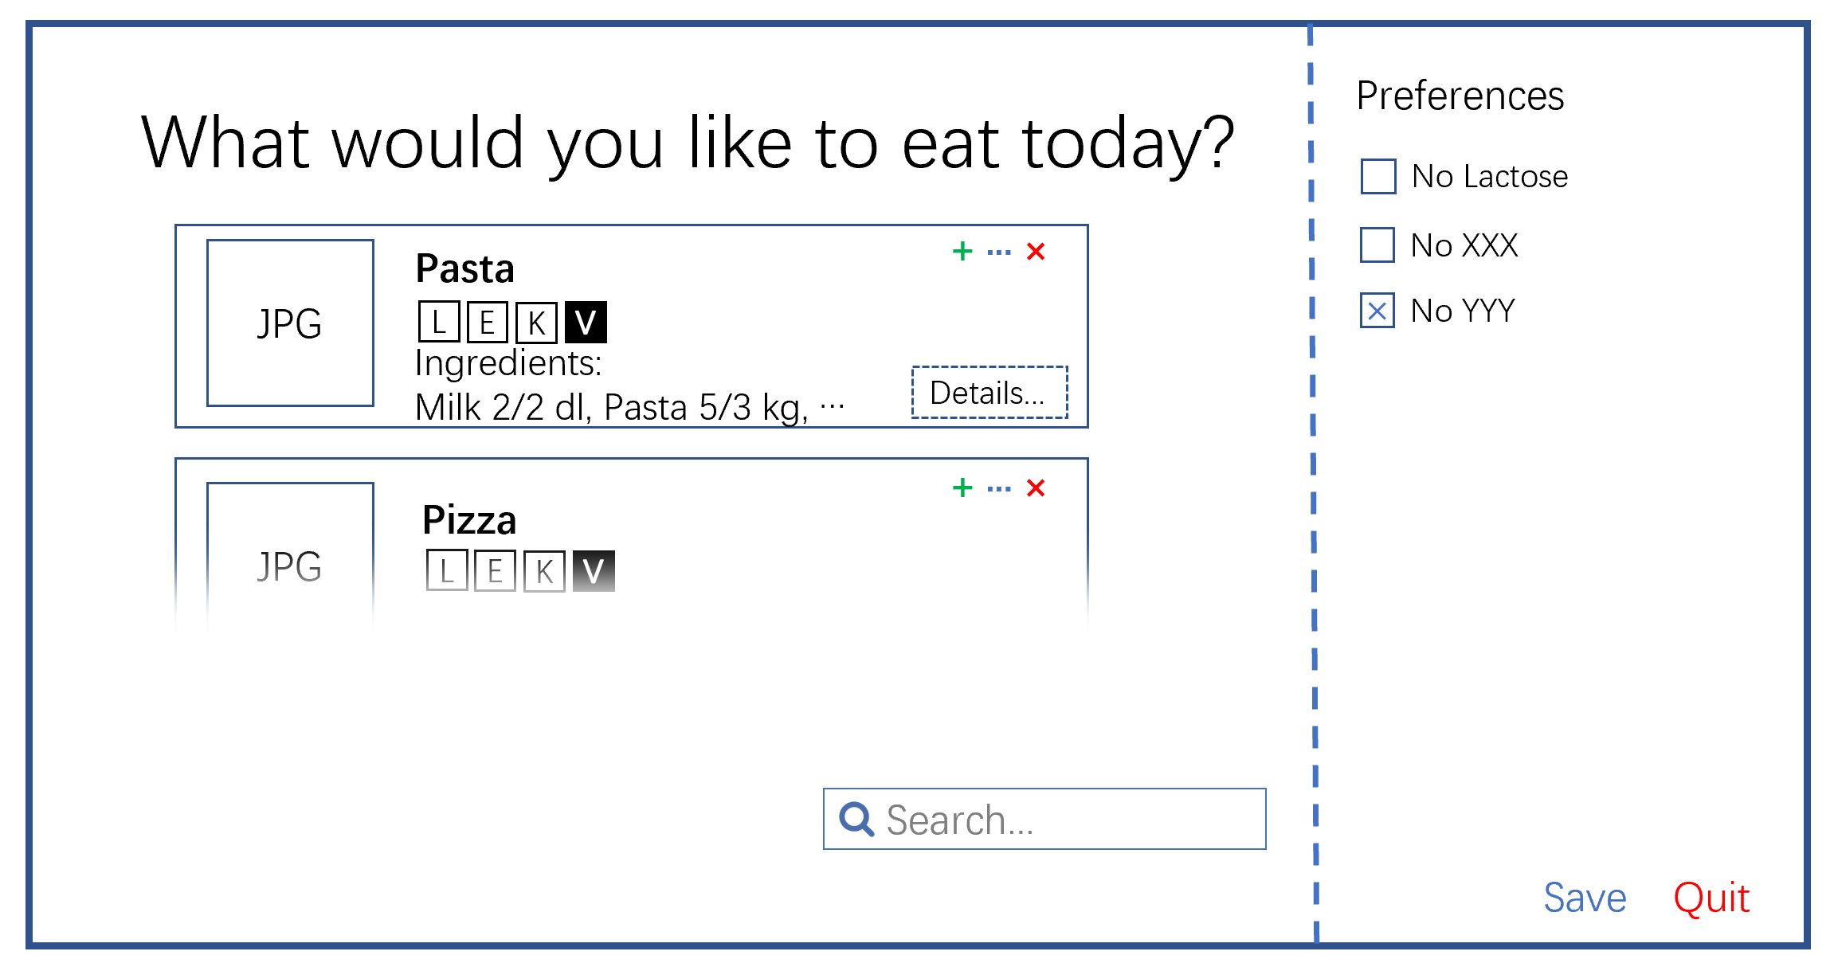

The program interacts with the user by checking a) the buttons clicked or boxes ticked b) input in the search box. The program present related information on the user interface. The program shows dishes based on selections of the user. With red x button, green + button and blue … button a user can delete, add or edit a recipe from the selection and save it in a text file.

**Files and file formats**

The program read and store the data in a .csv file or JSON/XML format depends on the data structure. When the program starts, it reads the file from the default directory. All data will be stored in a text-based file, and related photos of foods will be stored in a form of URL and fetched from the Internet.

**Plan for system testing**

The system can read a file and detect errors in the file by using unittests. The system is also going to be designed such that the system can tolerate some minor errors. The only input of the user is a string and will be filtered in the program, so there is no way that the user input crashes the program. The program will try to avoid undesired problems, such as stripping blank spaces for users to make the search function working. The test will also go through extreme conditions, such as no ingredients at all, no recipes at all, to test the function of the program.